Junior Mejia

DBMS

10/11/2021

**Out of Class 10-15 Problems**

Use the ConstructCo Database to complete the following problems.

1. Write a SQL command to retrieve assignment number, assignment date, employee number, employee first name, and employee last name.

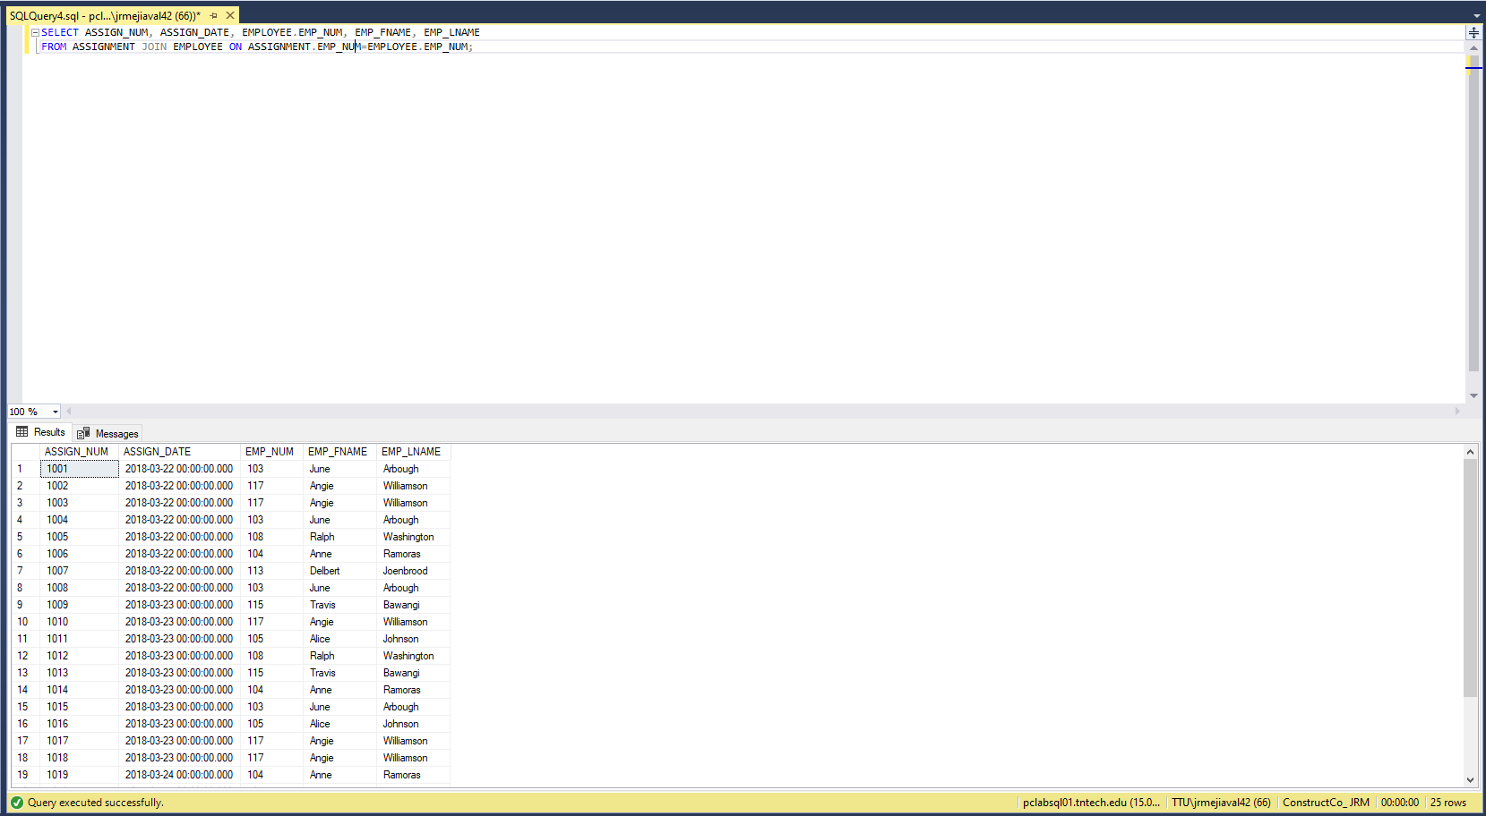

1. Add database aliases to the previous command and re-run your query.

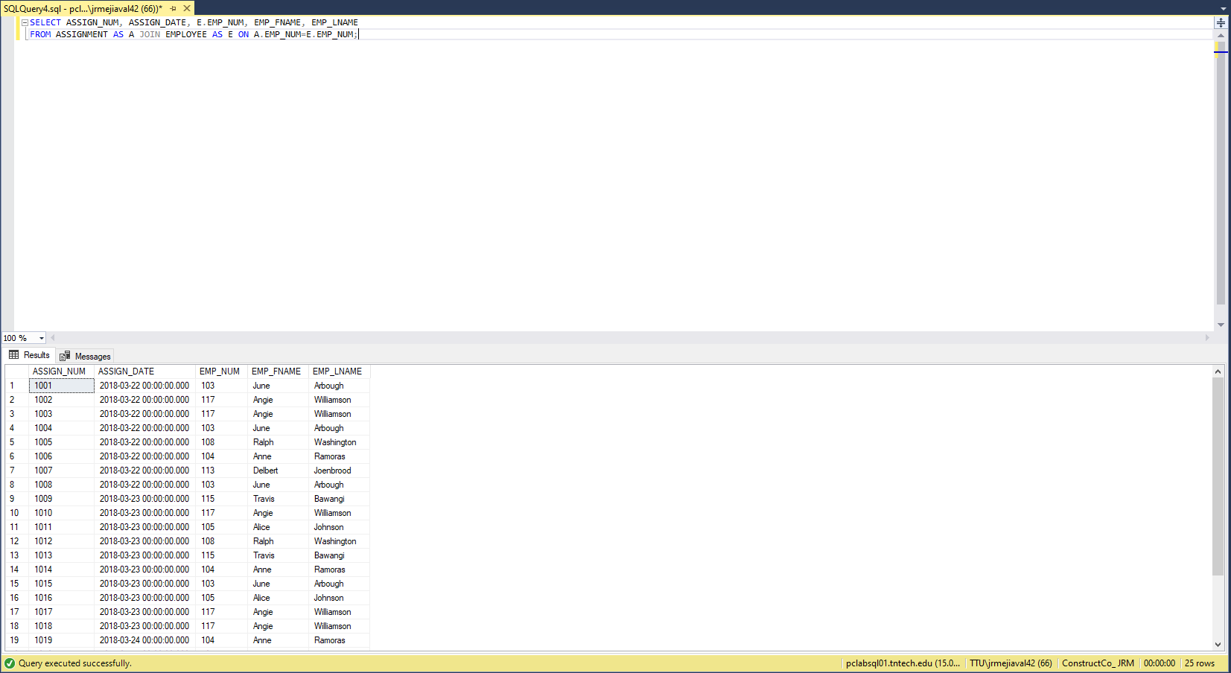

1. Add a where clause to search for emp_num = 117.

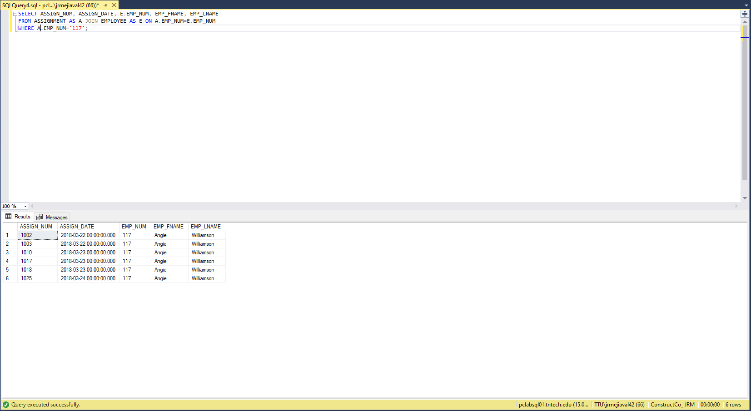

1. Store the above command in a stored procedure. When the stored procedure is run, the user should search for the emp_num.

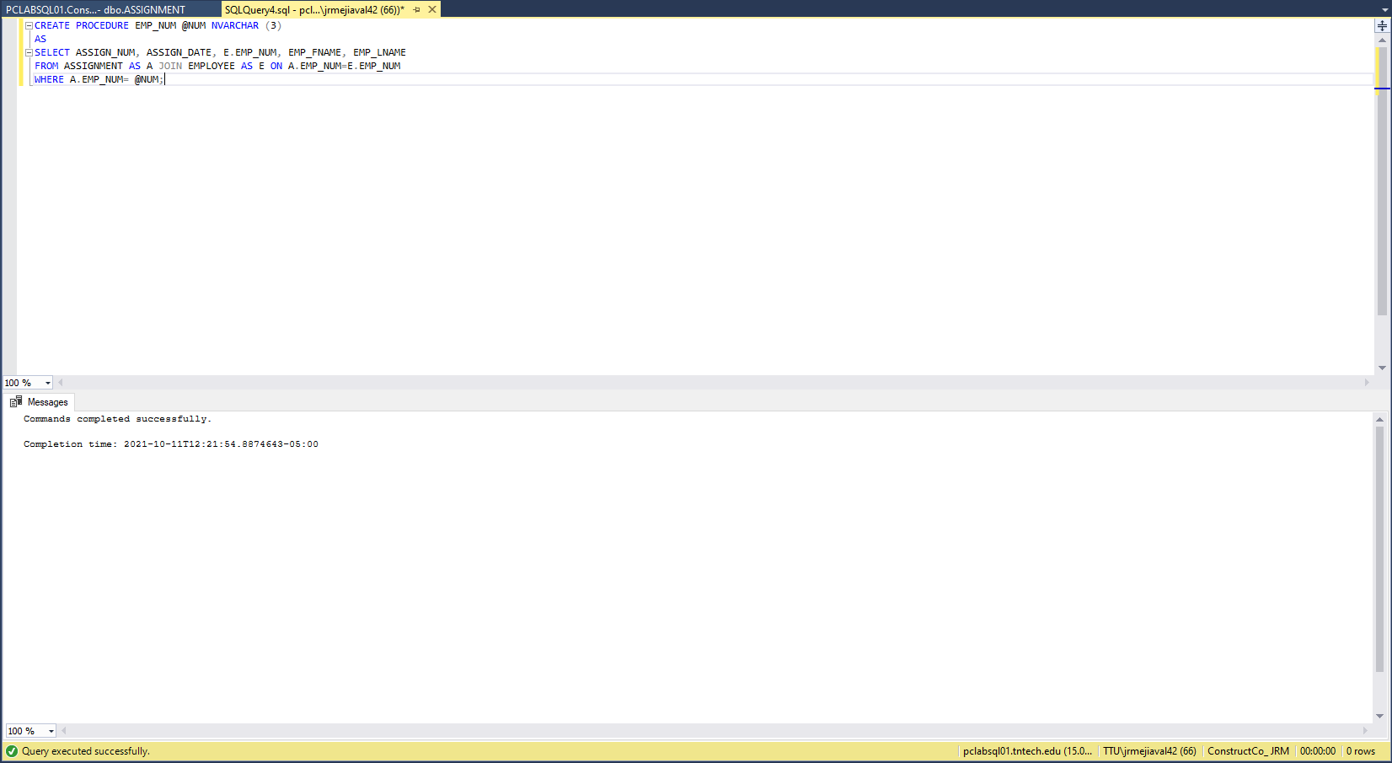

1. Execute stored procedure written in problem 4 and search for emp_num = 103.

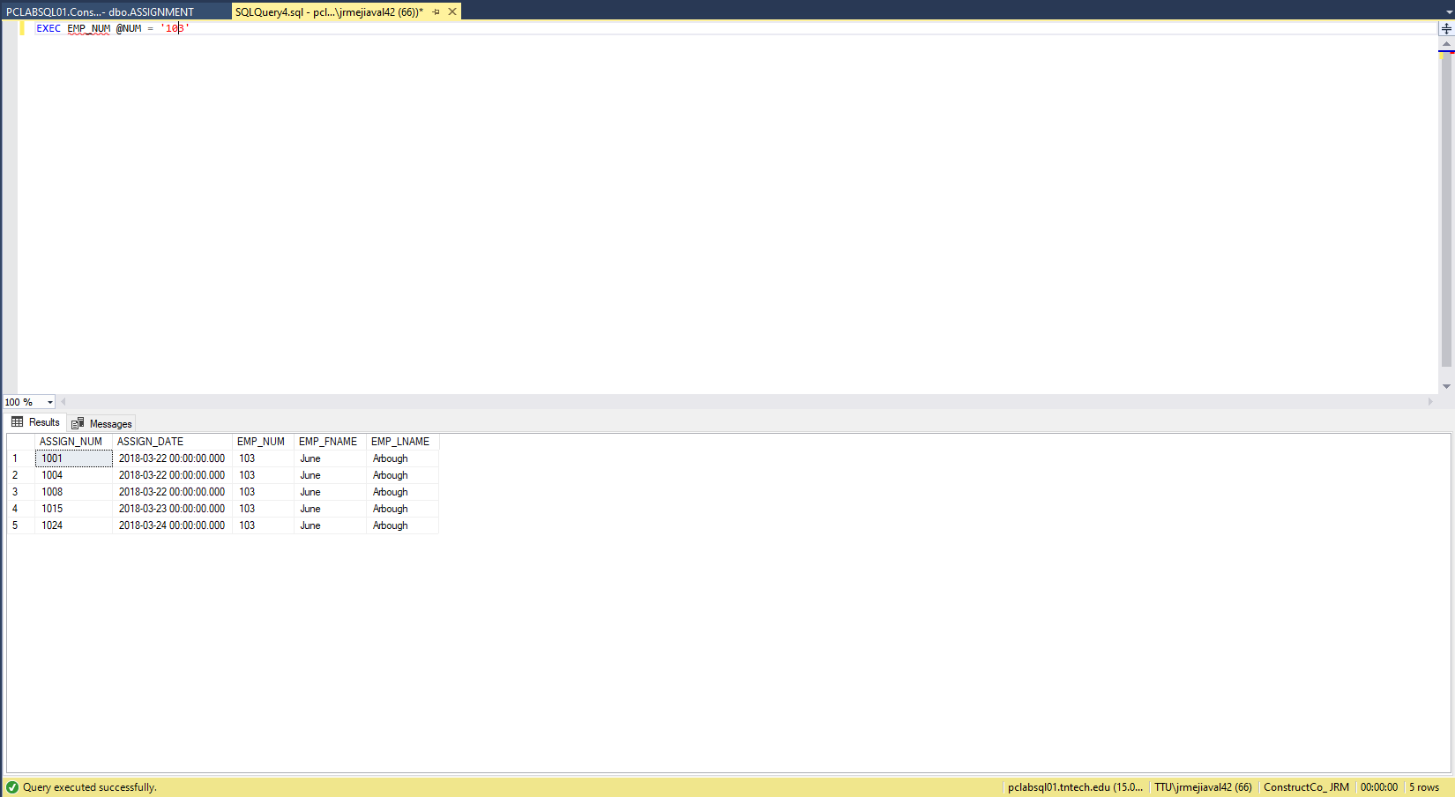

1. Create a stored procedure called ProjValue that shows job code, job description, job charge per hour, project number, project name, and project value where proj_num is like @projnum.

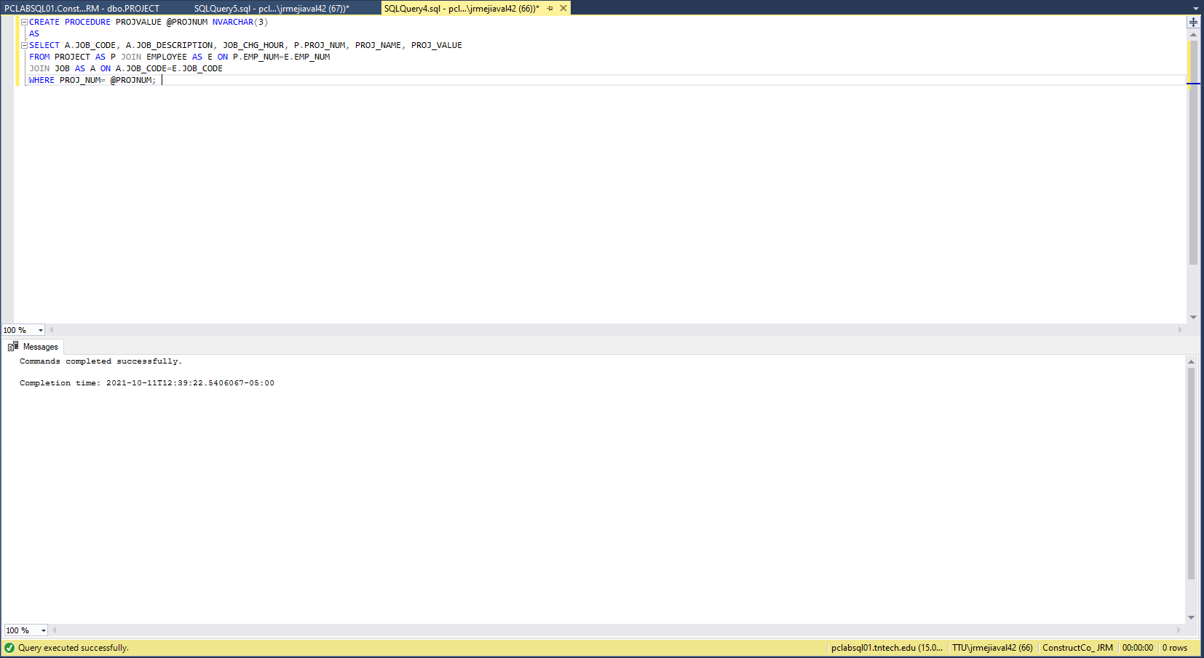

1. Execute your stored procedure to show the results where project number starts with the number 2.

